**For a fresh and upgradeable version of VariaMos Web (Front-End) we need to follow these stages (next we show a summary of each stage, the detailed steps can be found below):**

**Summary:**

1. Install HomeBrew **(only If you’re Mac user)** (**Homebrew** is a free and open-source software package management system that simplifies the installation of software on Apple's macOS operating system).
2. Install Git. (**Git** is a distributed version control system).
3. Install node.js and NPM (NPM is installed automatically when you install node). (**Node.js** is an open-source, cross-platform JavaScript run-time environment that executes JavaScript code outside of a browser. **NPM** is a package manager for the JavaScript programming language. It is the default package manager for the JavaScript runtime environment Node.js.
4. Install Visual Studio Code (Or your favourite code editor). **Visual Studio Code** is an open-source and free source code editor developed by Microsoft for Windows, Linux and macOS. It includes support for debugging, embedded Git control, syntax highlighting, intelligent code completion, snippets, and code refactoring. We recommend visual studio code, because it provides very useful plugins and elements to work with a vue project.
5. Create an account in GitHub.
6. Forking the project and cloning it into your local machine.
   1. Setting up the upstream repository (Sync your local fork with the original repository)
7. Installing the dependencies via NPM.
8. Running the server at localhost.

**Stage 1 - Install Homebrew (Only Mac Users)**

*Homebrew* […] simplifies the installation of software on the Mac OS X operating system.– [Homebrew – Wikipedia](http://en.wikipedia.org/wiki/Homebrew_%28package_management_software%29)

* Open the terminal window
* Copy & paste the following into the terminal window and hit **Enter**.

ruby -e "$(curl -fsSL https://raw.githubusercontent.com/Homebrew/install/master/install)"  
brew doctor

* You will be offered to install the ***Command Line Developer Tools*** from ***Apple***. Confirm by clicking ***Install***. After the installation finished, continue installing *Homebrew* by hitting **Enter** again.
* Copy and paste the following code to verify HomeBrew was correctly installed

**brew -v**

**Stage 2 - Install GitHub:**

**For Mac:**

Copy & paste the following into the terminal window and hit **Enter.**

**brew install git (You need homebrew for this command)**

You can use ***Git*** now, copy and paste the following code to verify Git works.

**git --version**

**For Linux:**

## ***Debian*-based linux systems**

* Open a terminal window.
* Copy & paste the following into the terminal window and hit **Enter. You may be prompted to enter your password.**
* **sudo apt-get install git**

**For Windows:**

* Download from the following site:

<http://git-scm.com/download/win>

* Once downloaded run the .exe and press next till you see this screen and select this option.

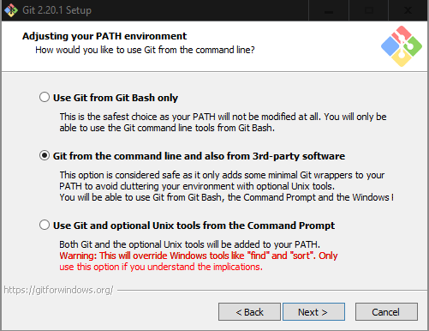

* Then press next (Default installation) till finish.

* Open Powershell



* You can use ***Git*** now, copy and paste the following code(**In PowerShell)** to verify

Git works.

**git --version**

**Stage 3 - Install Node.js:**

**For Windows:**

* Download from the following site you respective installer:<https://nodejs.org/es/download/>

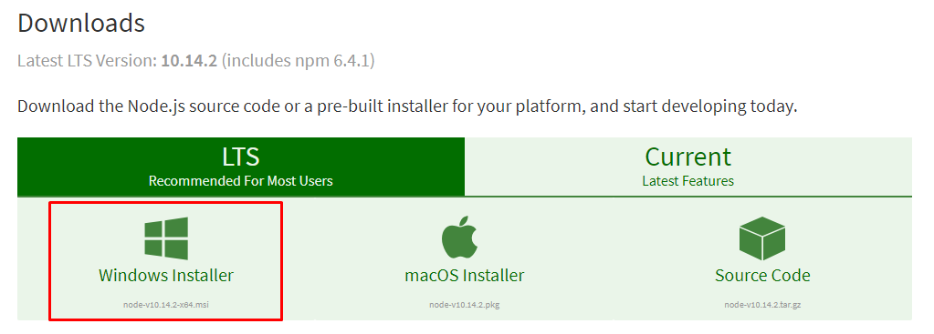

* Once downloaded, execute the .exe and press next till finish (Default installation).
* Open powershell
* You can use ***Node and NPM*** now, copy and paste the following code to verify it works:

**node -v**

**npm -v**

**For Mac:**

* Copy & paste the following into the terminal window and hit **Enter.**

**brew install node (You need homebrew for this command)**

* You can use ***Node and NPM*** now, copy and paste the following code to verify it works:

**node -v**

**npm -v**

**For Linux:**

## ***Debian*-based linux systems**

* Open a terminal window.
* Copy & paste the following into the terminal window and hit **Enter. You may be prompted to enter your password.**

**sudo apt install curl**

**curl -sL https://deb.nodesource.com/setup_8.x | sudo bash**

**sudo apt install nodejs**

* You can use ***Node and NPM*** now, copy and paste the following code to verify it works:

**node -v**

**npm -v**

**Stage 4 - Install Visual Studio Code:**

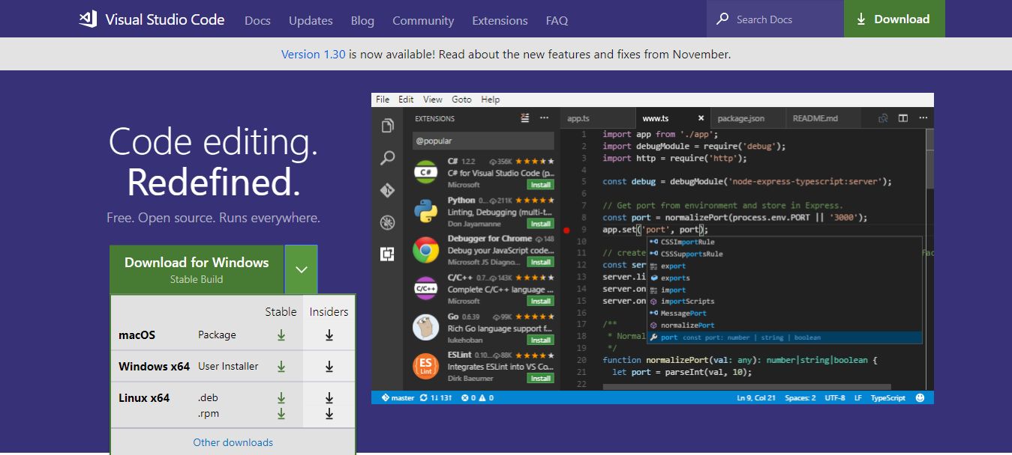

* Go to <https://code.visualstudio.com/download>, select your respective operative system and download the corresponding Visual Studio Code version.

**For Mac:**

* Double-click on the downloaded archive to expand the contents.
* Drag Visual Studio Code.app to the Applications folder, making it available in the Launchpad.
* Add VS Code to your Dock by right-clicking on the icon and choosing Options, Keep in Dock.
  + **(Optional to use “Code” alias in terminal)**
    - **Launch VS Code.**

Open the Command Palette (Ctrl+Shift+P) and type 'shell command' to find the Shell Command: Install 'code' command in PATH command.

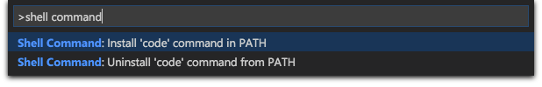

* + **Restart the terminal for the new $PATH value to take effect. Copy and paste the following code to verify it works.**

**code .**

**For Windows:**

* Once it is downloaded, run the installer (VSCodeUserSetup-{version}.exe). This will only take a minute.
* By default, VS Code is installed under C:\users\{username}\AppData\Local\Programs\Microsoft VS Code.
* Launch VS Code.

**For Linux:**

## ***Debian*-based linux systems**

* Download and install the .deb package (64-bit), either through the graphical software center if it's available, or through the command line with:

sudo apt install ./<file>.deb

# If you're on an older Linux distribution, you will need to run this instead:  
# sudo dpkg -i <file>.deb  
# sudo apt-get install -f # Install dependencies

* Then update the package cache and install the package using:

sudo apt-get install apt-transport-https  
sudo apt-get update  
sudo apt-get install code # or code-insiders

**Highlight support for .js .vue .html .css (Strongly recommended)**

* Launch VsCode (either via terminal or GUI)
* (Ctrl+Shift+X) in VsCode windows to open extensions market.

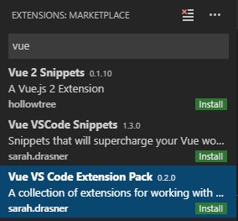

* Search and install these extensions:



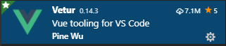

* Reload VSCode once everything was installed.

**Stage 5 - Create an account in GitHub:**

* Go to the following site: <https://github.com/>
* Click in Sign Up

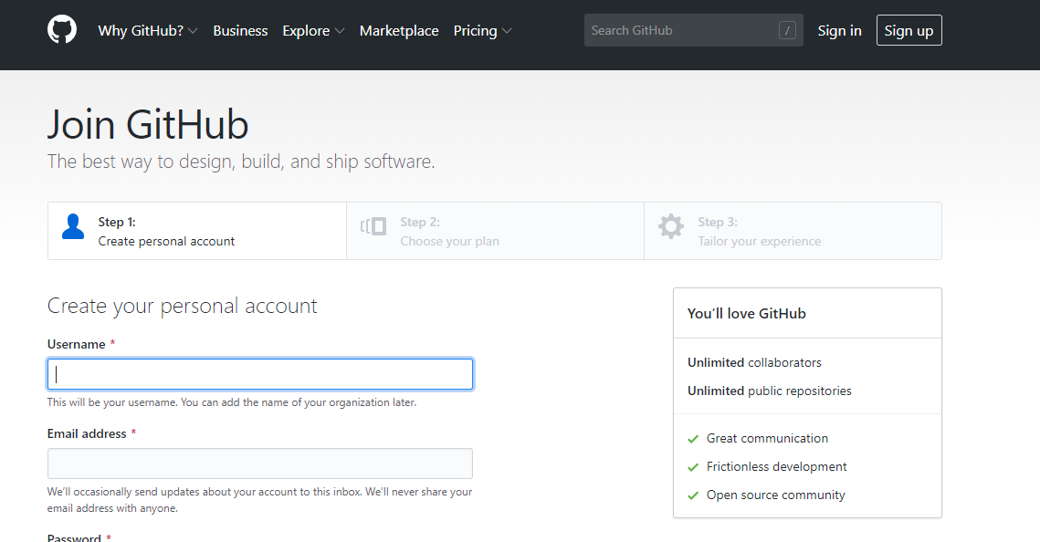

* Fill requested info, verify you’re human and proceed.

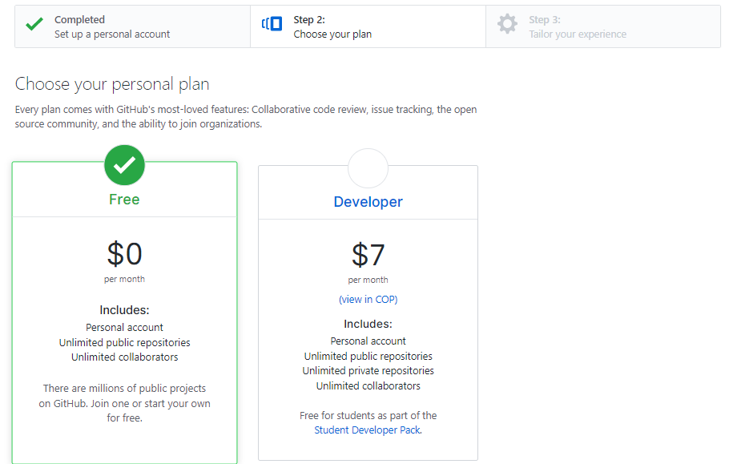

* Select your plan and proceed

1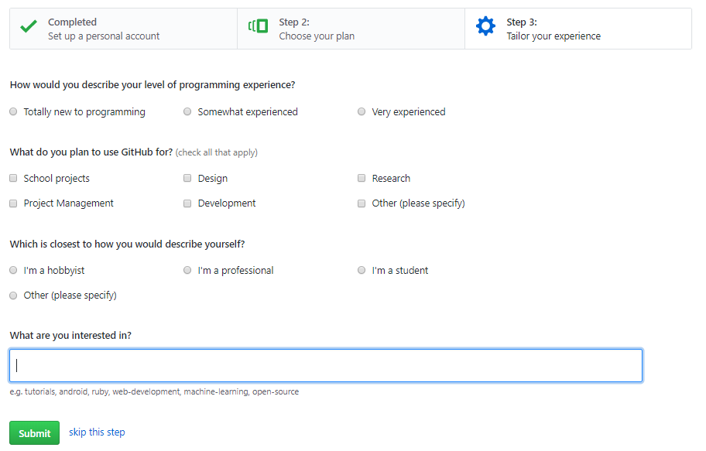

* Fill request info and click in submit (or skip).
* Verify your email address
* You can use ***Git*** with you new account now.

**Stage 6 - Forking the project and cloning it into your local machine:**

* Go to the following site: <https://github.com/SPLA/VARIAMOS-WEB>
* (Login if you aren’t logged in) Click in Fork 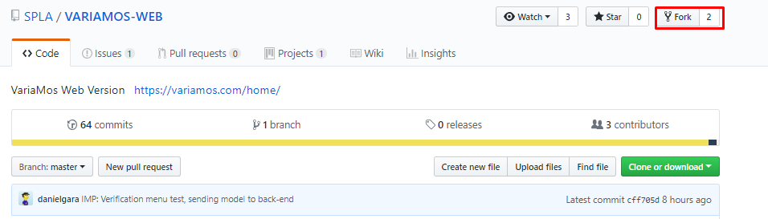
* If everything was ok, you should see instead of SPLA/VARIAMOS-WEB -> {your-username}/VARIAMOS-WEB

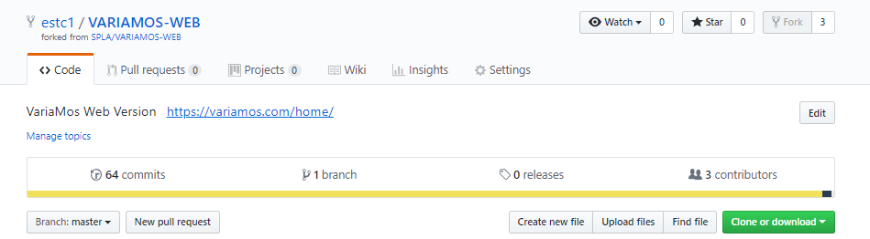

* Click in Clone or download and copy the URI clicking in the button highlighted in red in the image above.

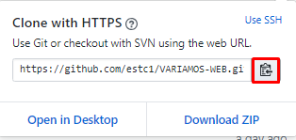

* Open Command prompt and get to the folder where you want to clone the project.
* Write the following code modifying the text in the curly brackets for your clipboard

git clone {your fork URI}

* To verify if it was correctly installed compare the output messages and should be similar to the image above:

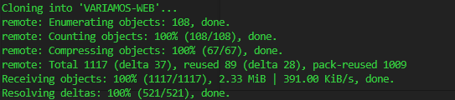

* Open the project with your favourite code editor (VSCode in this case) it should look similar to the following project structure:

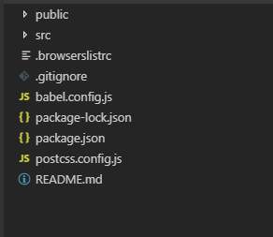

**Setting up the upstream repository (Sync your local fork with the original repository)**

* List the current configured remote repository for your fork with the following command:.

git remote -v

You should see something like this:

origin https://github.com/*YOUR_USERNAME*/*VARIAMOS-WEB*.git (fetch)  
origin https://github.com/*YOUR_USERNAME*/*VARIAMOS-WEB*.git (push)

* Specify the original repository to sync with your fork with the following command:

git remote add upstream https://github.com/SPLA/VARIAMOS-WEB.git

* Verify original repo was added in remote repository in your fork with the following command:

git remote -v

You should see something similar to the image above:

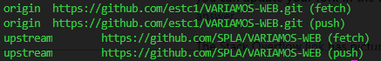

**Stage 7 - Installing dependencies via NPM**

* Open a command prompt
* Go to the directory where the project was cloned and copy & paste the following command: (It will take some minutes)

npm install

* If everything was ok, you should see something similar to the image above:

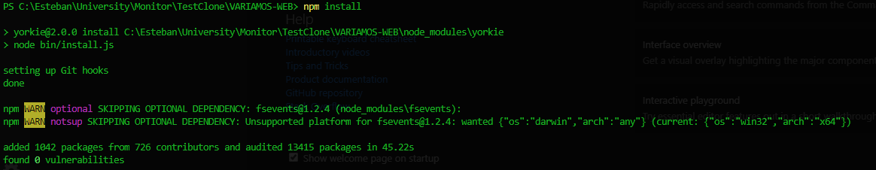

**Stage 8 - Running the server at localhost:**

* Open a command prompt
* Go to the directory where the project was cloned and copy & paste the following command:

npm run serve

Vue will start to create a local server at port 8080, (it would take some minutes), when everything is setted up you should see something similar to the following image:

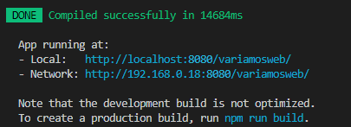

* Open your favourite web browser and copy and paste the local URI then press **Enter**

If everything was ok, the result will be a deployed server (Local) where is the current project code working. (For example: <http://localhost:8080/variamosweb/> )

